CHAPTER 1
ADMINISTRATION AND REPORTING

TABLE OF CONTENTS

Page
1.0 Introduction 2
1.1 Project Start-up 2
1.1.1. Pre-Agreement Strategy 2
1.1.2 Grant Agreement Execution 3
1.1.3 Establish a Local Administrative Structure 4
1.1.4 Administrative Thresholds 5
1.1.5 Public Participation 9
1.1.6 Key Geographic Terms 10
1.2 Reporting and Recordkeeping 11
1.2.1 Establish a Record-keeping System 11
1.2.2 Conflict of Interest 11
1.2.3 Grant Overview Information 13
1.2.4 Payment Requests and Progress Reports 13
Resources 14

CHAPTER 1
ADMINISTRATION AND REPORTING

1.0 Introduction

Prior to implementing any work on a TxCDBG project, a Grant Recipient should put systems in place to track and report on project activities as required by the TDA Grant Agreement. This chapter highlights the essential steps and concepts needed for successful project management.

1.1 Project Start-up

1.1.1. Pre-Agreement Strategy

The Pre-Agreement Strategy refers to pre-award costs incurred by the Grant Recipient, directly in accordance with the proposed project and in anticipation of the TxCDBG Grant Agreement. Such costs must be necessary to comply with the proposed delivery schedule or period of performance and are allowable only to the extent that they would have been allowable after the regular start date of the TxCDBG Grant Agreement. Allowable costs must have the written approval of TDA. All existing grant rules apply to the pre-agreement period.

The grant application includes an opportunity to request approval to utilize the pre-agreement strategy in order to pursue early implementation of the proposed project. TDA will notify the Grant Recipient if, in its sole discretion, the agency declines the pre-agreement request. Fund specific requirements and restrictions on the type of activities eligible as pre-agreement costs are addressed in each fund’s Application Guide.

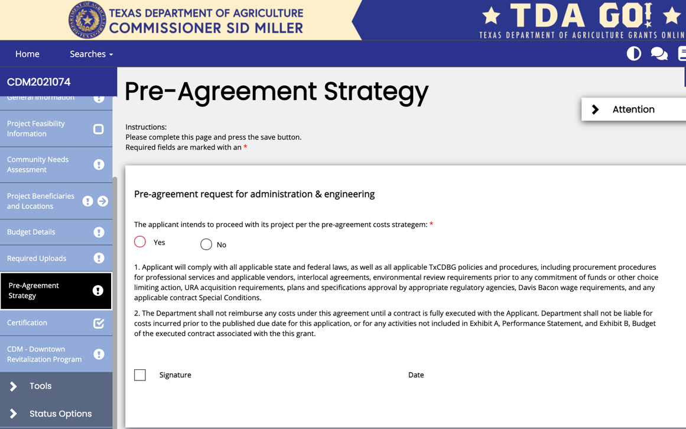
Figure 1. Pre-Agreement Strategy signature page

TDA will allow the Grant Recipient to incur costs for CDBG activities before the TxCDBG Grant Agreement start date and to charge these pre-agreement costs to the grant, provided that the activities are:
- Eligible costs
- Meet the objectives of the program; and
- Are authorized pursuant to applicable state and/or federal law.

To be eligible for either TxCDBG grant funding or match funding, costs incurred during the pre-agreement phase must occur:
- On or after the TDA pre-agreement date found in the TxCDBG Grant Agreement Exhibit B, Section B;
- On or after the administrative or engineering services contract award date – formal approval by elected body; and
- During the contract period identified in the administration/engineering services contract, i.e., Time of Performance in Appendices D and E, the services contract period may begin prior to the date that the services contract was executed.

NOTE: The Grant Recipient may not incur costs or expend any project funds for construction prior to:
- Meeting the Environmental Review requirements in the TxCDBG Grant Agreement, see Chapter 3 Environmental Review; and
- Meeting all special condition requirements of the TxCDBG Grant Agreement for the release of construction funds, see Chapter 4 Grant Agreement Special Conditions.

1.1.2 Grant Agreement Execution

In addition to the TxCDBG Grant Agreement obligations between the state and the Grant Recipient, the Grant Agreement includes the following exhibits:
- Exhibit A – Performance Statement and Award Specific Conditions –
- Section A Eligible Uses of Funds – The Performance Statement outlines the scope of the work to be performed under this Grant Agreement by activity,
- Section B Prohibited Activities – This standard clause reflects activities that cannot be funded through TDA grants,
- Section C Timeline – The Timeline identifies key dates for the Grant Agreement period. Failure to meet these milestones may impact the Grant Recipient for the current grant and/or future grant applications, and
- Section D Special Conditions – Provisions 1 through 8 are specific to Community Development Block Grants, followed by special conditions specific to the requested project.
- Exhibit B – Project Budget – Exhibit B specifies the agreement’s budget by line item, including matching funds committed by the Grant Recipient that are necessary to complete the project described in the Performance Statement;
- Exhibit C – General Terms and Conditions – Exhibit C includes standard provisions for federal grants; and
- Exhibit D – Certifications and Assurances – Exhibit D includes standard certifications to which all TxCDBG Grant Recipients must agree.

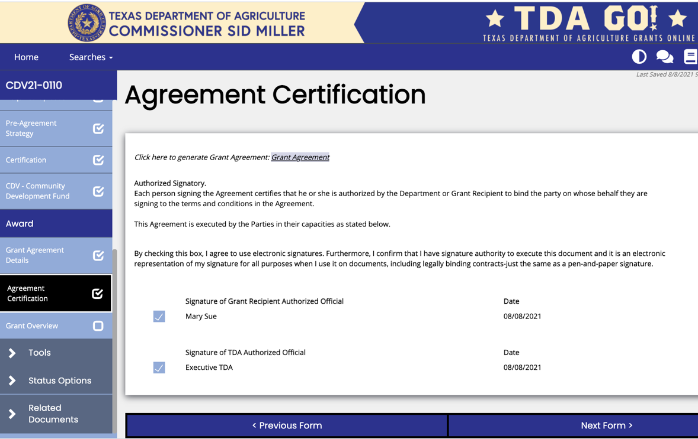
Figure 2. How to view your grant

The Grant Agreement is considered executed in TDA-GO after two certifications are completed:
- the chief local official for the Grant Recipient or other local official, designated by resolution and registered in TDA-GO as the Authorized Official (AO), and
- the authorized TDA designee.

NOTE: In TDA-GO, clicking the Save button only saves information entered into the on-screen fields. The Status must also be changed to send the information to TDA.

Ready to Proceed Rule
Prior to executing the TxCDBG Grant Agreement, TDA will ensure that any existing Grant Agreements are in good standing and any outstanding issues are resolved to TDA’s satisfaction within ninety (90) days after the grant award date. This includes, but is not limited to:
- Readiness to proceed issues regarding the current award; and
- Outstanding issues on existing grants regarding compliance with program requirements.

If the outstanding issues identified by TxCDBG staff at the time of the funding award are not addressed within the required ninety (90) days, TDA will not execute the Grant Agreement and the TxCDBG funds awarded may be withdrawn and reallocated.

1.1.3 Establish a Local Administrative Structure

Each Grant Recipient must establish a local administrative structure to complete the grant. The eligible activity and National Program Objective (NPO) requirements are not met until the project is completed, beneficiaries are served, and there is appropriate documentation to ensure that the project is consistent with the designated NPO.

When establishing a local administrative structure, the Grant Recipient must:
- Establish a record-keeping system to document compliance with all federal, state, local, and program requirements by:
- Keeping all grant files at city or county offices or buildings in which government records are maintained and accessible to the public throughout the Grant Agreement period; and
- Retaining all records for the greater of four (4) years from closeout of the grant to the state, or the period required by other applicable federal and state laws and regulations.
- NOTE: Each TxCDBG subgrant is funded by a larger grant from the U.S. Department of Housing and Urban Development; “closeout of the grant to the state” refers to when this total sum is exhausted. This should not be confused with the closeout of the grant to the individual subrecipient or “Grant Closed” (formerly referred to as “Administratively Complete”). Refer to the TxCDBG website for the current record retention schedule. Review and comply with all local charters, resolutions, ordinances, and policies that may be relevant to the project; and
- Determine whether day-to-day administration of the project will be conducted by local staff or by a certified third-party consultant, and which party will conduct each administrative activity.

NOTE: TxCDBG Grant Recipients have the final legal responsibility for the locally maintained grant files, the timely submission of reports, and compliance with program guidelines.

BEST PRACTICE: TxCDBG recommends that the Grant Recipient review the Administrative Activities Checklist (Form A102), item-by-item, and identify the activities to be performed by the Grant Recipient’s staff and those that will require outside assistance. It is also helpful to walk each staff member responsible for implementing the grant through the TxCDBG program requirements.

1.1.4 Administrative Thresholds

Project Schedule
The Grant Recipient will comply with the project schedule included in the Grant Agreement. Failure to meet any of the milestones below may result in sanctions, as outlined in the TxCDBG Implementation Manual, Texas Administrative Code, other published guidance, and the conditions of the Grant Agreement.

Milestone | Standard consequences for failure to  satisfy the milestone on or before the date  identified in the Grant Agreement
Environmental review/plans and specifications recommended to be complete | Scoring penalty may applied to future grant applications.
Group B forms required to be complete | The Grant Recipient is ineligible to apply for future grant awards until the milestone is satisfied and/ or TDA may initiate grant termination.
Project recommended to be complete, including inspections | N/A – There is no standard penalty for failure to meet this milestone. However, additional technical assistance may be required based on project circumstances.
Grant Agreement period ends | If a Grant Agreement extension is required, the Grant Recipient is ineligible to apply for future grant awards until the existing project is documented as complete.
Final payment and closeout documentation required to be submitted | Deobligation of all remaining grant funds.

Document Groups
TDA program requirements use several document groupings to implement certain thresholds. The documents required to be considered in compliance with each group are listed below:

Group A Documents
- Executed TxCDBG Grant Agreement;
- Grant Overview – The Primary Administrative Contact within TDA-GO fields, Labor Standards Officer, and Civil Rights Officer fields must be completed;
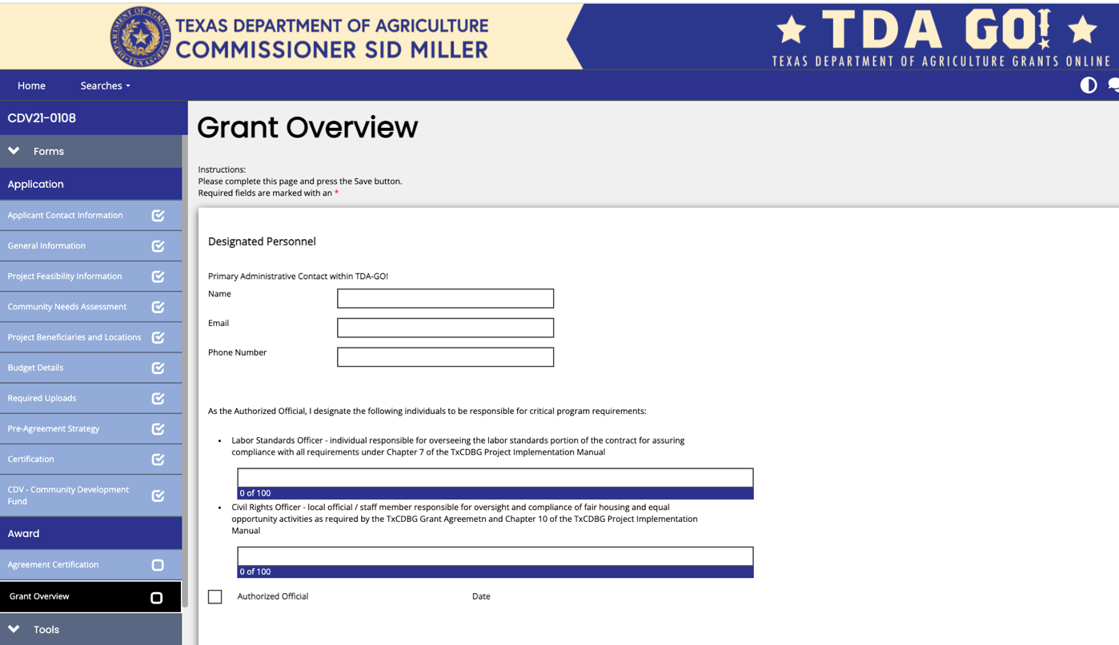
Figure 3. Grant Overview page

- Performance Report – Group A Report – Upload all documents identified and complete all applicable fields, see Chapter 10 Civil Rights:
  - Resolution adopting or reaffirming community policies to comply with civil rights requirements,
  - Fair housing activities,
  - Required Non-discrimination Notices, and
  - Limited English Proficiency (LEP) plan – This plan must be specific to the location and the community or area served by the current project.
- Banking and Financial Documentation – see Chapter 2 Financial Management for details on submitting banking and financial information to TDA:
  - Direct Deposit Authorization Form (Form 74-176),
  - Federal Request for Taxpayer Identification Number (TIN) (Form W9), and
  - State Application for TIN.
- Related Documents – Materials and Services Report (MSR): The MSR must be submitted and accepted for each requested vendor or services provider, see Chapter 5 Procurement Procedures. At a minimum, an MSR for administrative services and engineering services, if applicable, is expected unless the use of force account has been approved for these services, see Chapter 8 Force Account.

Group B Documents
- Grant Overview – For the Special Conditions section, upload documentation needed to satisfy all pre-construction related conditions, see Chapter 4 Grant Agreement Special Conditions;
- Performance Report – Environmental Review. Authority to Use Grant Funds (AUGF) is approved by TDA staff, see Chapter 3 Environmental Review;
- Performance Report – Real Property Acquisition. Acquisition Plan page AND Acquired Parcel page must be completed for each property related to the construction activity, see Chapter 6 Acquisition;
- Performance Report – Group B Report – Upload these documents and complete all applicable fields,
  - Section 3 presentation meeting notes and/or agenda from a public meeting, and
  - Photo of temporary signage.
- Related Documents – Materials and Services Report (MSR) – A separate MSR must be completed for each requested vendor or services provider. To satisfy Group B, at least one MSR submitted in TDA-GO must document execution of a contract for construction. Non-construction grants must document execution of a contract for the primary grant activity, see Chapter 5 Procurement Procedures.

Group C Documents
- Performance Report – Group C Report – Certified administrator and Labor Standards Officer must complete all applicable fields.

Construction Complete Group Documents
- Grant Overview – For the Special Conditions section, upload documentation needed to satisfy all construction-related conditions, see Chapter 4 Grant Agreement Special Conditions;
- Related Documents – Materials and Services Report (MSR)– All sections, including the MSR Final Wage Compliance (if applicable) and Work Completed pages, must be completed for all vendors or services providers, documenting the following:
  - All programmatic requirements are met,
  - All claims and disputes have been settled,
  - All warranties have been received, and
  - All liens have been released, see Chapter 5 Procurement Procedures; and
- Related Documents – Payment Requests – Invoices or similar documentation for costs greater than or equal to the amount of matching funds required by the Grant Agreement.

Project Complete Group Documents
- Final payment request,
- Project Completion Report (PCR), and
- All requested documentation for monitoring review(s), see Chapter 13 Monitor Review.

The Mid-Point Progress Threshold
The Grant Recipient must submit all Group A and Group B documents by the date identified as Group B Forms Required to Be Complete in the Grant Agreement Exhibit A, Section C Timeline.

If a Grant Recipient fails to meet this requirement, TDA will begin the process of Grant Agreement termination. The TxCDBG Grant Agreement ensures that the Grant Recipient will have an opportunity to resolve the deficiency as a part of the termination proceedings. For non-compliance with the Mid-Point Progress Threshold, TDA will initiate a Mid-Point Progress Report in TDA-GO. The Grant Recipient must complete and submit this report within thirty (30) days of the report’s initiation, providing a justification for the delay and a schedule detailing milestone dates for completing the Group A and Group B requirements. TDA will evaluate the response and may continue termination proceedings or suspend those proceedings pending documentation of the Grant Recipient’s progress based on the newly proposed timeline.
NOTE: All funds may be placed on hold while the Grant Recipient is out of compliance with the progress milestone.

Progress Thresholds for New Applications Submitted After the Award of a TxCDBG Grant Agreement
The Grant Applicant must demonstrate satisfactory progress in all current open Grant Agreements to be eligible to submit a new application. The following table illustrates the progress threshold requirements for each TxCDBG fund category.

NOTE: The Grant Applicant Progress Thresholds included in each application guide may vary from the example table below; each Application Guide and applicable thresholds will supersede this section.

Fund Category | Original Agreement Period | Mid-Point Progress Threshold | Final Progress Threshold
State Urgent Need Fund | 18 months | 12 months after  agreement start date | 18 months after  agreement start date
Disaster Relief Fund | 12 months | 9 months after  agreement start date | 12 months after  agreement start date
FAST Fund | 18 months |  | 18 months after  agreement start date
Community  Development Fund | 24 months | 12 months after  agreement start date | 24 months after  agreement start date
Downtown Revitalization/  Main Street Fund | 24 months
Colonia Fund  (Except Self-Help) | 24 months
Planning Capacity  Building Fund | 24 months
Community  Enhancement Fund | 24 months

There are two types of Progress Thresholds, each applicable to TxCDBG Grant Agreements where the Grant Agreement start date is at least the identified number of months prior to the application due date under consideration.

- Mid-Point Progress Threshold Requirement – This rule requires applicants for future TxCDBG funding with existing TxCDBG Grant Agreements for which the threshold date has passed to submit all Group A and Group B documents for that Grant Agreement to be eligible to submit a new grant application.

- Final Progress Threshold Requirement – This rule requires the Grant Recipient to complete its TxCDBG project prior to applying for future TxCDBG funding. The Grant Recipient is considered to have met the Final Progress Threshold if:
- All activities in the TxCDBG Grant Agreement’s Performance Statement are complete;
- A payment request for all remaining TxCDBG funds, excluding single audit costs and other costs explicitly approved in writing as reserved funds by the TxCDBG Director, has been submitted; and
- The Project Completion Report (PCR) has been submitted via TDA-GO.

In very limited instances in which the Grant Recipient cannot meet this requirement, please refer to Chapter 12.2.2 Conditional Project Completion. Grants that do not meet the parameters for Conditional Project Closeout will be held to the Final Progress Threshold even if the reasons for the delay are outside of the Grant Recipient’s control.

This threshold will not prevent an eligible applicant from receiving TxCDBG State Urgent Need (SUN) Fund assistance when the applicant meets the eligibility criteria for the SUN Fund.

1.1.5 Public Participation

TxCDBG applicants and funded Grant Recipients are required to carry out public participation in accordance with the Citizen Participation Plan adopted for the TxCDBG Program. In this section, the term “Grant Recipient” includes applicants for TxCDBG funding. By submitting the TxCDBG application and Grant Agreement, the Grant Recipient certifies that it has and will comply with the requirements of this Citizen Participation Plan.

Each Grant Recipient must maintain a citizen participation file that includes the applicant's complaint procedures, any technical assistance provided by the applicant, and public notices, minutes, and attendance lists for public hearings.

Complaint Procedures
The Grant Recipient must have written citizen complaint procedures that provide a timely written response to complaints and grievances. Residents must be made aware of the location, days, and hours when copies of the procedures are available.

Technical Assistance
When requested, the Grant Recipient shall provide technical assistance to groups representative of persons of low-to-moderate income in developing proposals for the use of TxCDBG funds. The level and type of assistance shall be determined by the Grant Recipient based upon the specific needs of the community's residents.

Public Hearing Provisions
A key component of the program is the opportunity for residents to express their needs and concerns, regarding TxCDBG funded projects, to the Grant Recipient.
- The Grant Recipient must hold a public hearing prior to authorizing submittal of the grant application.
- If the project is funded, the Grant Recipient must hold a public hearing concerning any proposed substantial change, as determined by TDA, in the use of TxCDBG funds, see Chapter 11 Grant Agreement Amendments.
- Upon completion of all project activities, the Grant Recipient must hold a public hearing and review its program performance, including the actual use of TxCDBG funds.

Public hearings, as required by the fund specific Application Guide and Chapters 11 and 12 and Section B of this manual, must comply with the following:
- Hearings must be held in a location convenient to the project beneficiaries;
- Hearings must be held at, or after, 5 p.m. on a weekday or on a Saturday or Sunday;
- Grant Recipient must provide accommodations for citizens with disabilities;
- Hearings must be conducted in a manner to meet the needs of non-English speaking residents where a significant number of non-English speaking residents can be reasonably expected to participate. The Grant Recipient must adhere to its Limited English Proficiency (LEP) Plan, see Chapter 10 Civil Rights;
- Grant Recipient must provide notice of the hearing to citizens at least seventy-two hours (three days) prior to the scheduled hearing — including the date, time, location of the hearing, and the topics to be considered; and
- Records related to the hearing must be made available to the public. Required documentation includes the public hearing notice, sign-in sheet with a list of attendees, the minutes of the hearing, and a summary of public comment(s).

Public Notice Provisions
Public Notices are required at several stages of the grant, as described in each fund’s Application Guide and Chapters 3, 10, 11, and 12, and Section B of this manual.
- Public Notice may be given in one of three ways:
- Publish the notice in a newspaper of general circulation;
- Post the notice in at least two public places accessible to the general public at the time of the posting including the courthouse/city hall and a location within the target area (if applicable); OR
- Post the notice in one public place accessible to the general public at the time of the posting, such as the courthouse/city hall, and post on Grant Recipient’s website.
- Posted Notices must be in a location accessible to the general public at the time of the posting.
- The Public Notice must include all required information in English and any other appropriate language(s) per the Grant Recipient’s LEP plan, see Chapter 10 Civil Rights.
- The Grant Recipient must retain the following documentation of the Public Notice:
- Published Notices – Submit to TDA either a copy of the notice or the full newspaper page on which the notice occurred.
  - The publication text, title, date of publication, name of the newspaper, and page number must be clear and readable, and supported by affidavit, see Affidavit of Posting - Citizen Participation Public Hearing (Form A101).
  - The original newspaper tear sheet or a photocopy of the notice and a publisher’s affidavit must be kept with the Grant Recipient’s local file for the public, TDA monitors, and other state or federal inspectors.
- Website Notices – Screen shots of the notice, with the date visible, must be retained as documentation of the posting.
- Posted Notices – Legible photographs showing the location of the posting are required.
- Posted Notices – Must be supported by affidavit, see Affidavit of Posting - Citizen Participation Public Hearing (Form A101).

1.1.6 Key Geographic Terms

The TxCDBG program relies on several key geographic areas to determine eligibility and compliance requirements for each project.

Project Area/Location – This term is used when identifying the physical location of infrastructure improvements, facilities, or other elements of the project.

Benefit Area – This term identifies the location of all households benefiting from the project. Refer to the TxCDBG Guide to Meeting a National Program Objective, located on the TDA website, for guidance on identifying this area for each type of project.

Census Geography – This term refers to geographic areas designated by the U.S. Census Bureau, such as census tracts, block groups, and blocks. Census data provided based on these geographies may be used for scoring and/or income documentation purposes as allowed by program requirements; however, these geographies are not a substitute for properly identifying the benefit area of a project.

Grant Recipient’s Jurisdiction – The county boundaries or city limits may be important to defining certain projects and the jurisdiction within which the Grant Recipient has authority to implement the project. While these boundaries alone do not define a benefit area, some services may be provided solely or primarily within a Grant Recipient’s jurisdiction.

Environmental Review – Aggregate Project Area – This area includes the physical locations of all work funded by the project, AND all work that is geographically or functionally related to the project even if not funded by the grant, and the surrounding areas impacted by such work, see Chapter 3 Environmental Review.

Section 3 Service Area – This area surrounds the physical location(s) of grant funded construction work and identifies geographic area where potential workers may reside. This area must have a minimum population of 5,000 persons, see Chapter 10 Civil Rights.

Geographies for Specific Fund Categories – see the fund specific Application Guide for additional details:
- Colonia area – an unincorporated community located in a non-metropolitan county within 150 miles of the Texas-Mexico border, established prior to November 1990, and lacking public infrastructure.
- Downtown Area – traditional economic center of a TxCDBG community.
- Main Street Area – the area identified as part of the Texas Historical Commission (THC) Main Street Program.
- Blighted Area – the area identified by local resolution as meeting the HUD definition of a slum or blighted area. Grant Recipients should not designate the entire community or entire downtown area as blighted unless the entire area meets the definition.
- Emergency Service Provider’s Service Area – the area where the service provider is the primary provider for fire or EMS services. This area may or may not align with city or county boundaries and excludes geographies where the entity provides mutual aid.

1.2 Reporting and Recordkeeping

1.2.1 Establish a Record-keeping System

Grant files must be kept at city or county offices or buildings in which government records are maintained and be accessible to the public throughout the Grant Agreement period. Any alternate record storage location must be approved in writing by TDA. All records included in Filing System Guide (Form A103) must be included in the local records.

Records shall be retained for a minimum of four (4) years from closeout of the grant to the state. TDA will announce the closeout of each state grant and the individual Grant Agreements that may begin the four-year retention period.

Documents must be submitted to TDA through TDA-GO unless specifically requested in another format. However, documents cannot be uploaded nor accessed on platforms such as Google docs, Dropbox, etc. due to security risks and such action is considered a violation of TDA security policy.

1.2.2 Conflict of Interest

The Grant Recipient must identify any potential conflicts of interest for the TxCDBG funded project. Conflict of interest provisions apply to:
- Any person or entity including any benefitting business, utility provider, or other third-party entity that is receiving assistance, directly or indirectly, under a TxCDBG Grant Agreement or award; or
- Any person or entity that is required to complete some or all work under the TxCDBG Grant Agreement in order to meet a National Program Objective (NPO), that might potentially receive benefits from TxCDBG awards.

The general rule is that no person/entity described above:
- Exercises or has exercised any functions or responsibilities with respect to TxCDBG activities;
- Is in a position to participate in a decision-making process; or
- Is in a position to gain inside information with regard to such activities may obtain a financial interest or benefit from a TxCDBG-assisted activity, or have a financial interest in any contract, subcontract, or agreement with respect to a TxCDBG-assisted activity, or with respect to the proceeds of the TxCDBG-assisted activity, either for themselves or those with who they have family or business ties, during their tenure or for one (1) year thereafter.

TDA will evaluate persons in similar roles for benefitting organizations, such as utilities providing service through the project or businesses creating jobs as a result of the project, in determining a conflict of interest. The person may not have an interest in any contract or agreement related to the TxCDBG proceeds/program for themselves or their family/business ties during their tenure or one year after conclusion of their tenure.

Any conflict of interest or apparent conflict of interest must be disclosed to TDA in writing as soon as it is known. TDA, in its sole discretion, will determine whether the situation meets the program definition for a conflict of interest.

EXAMPLE: Central City, Texas applied for TxCDBG funds for a first-time sewer project in the West Addition neighborhood. One of the residents included in the project is the mother-in-law of City Council member Bob Thompson. Councilman Thompson does not have a financial interest in the project; however there is a conflict of interest due to the TxCDBG funded benefit to be provided to his family member.

Exception to Conflicts of Interest
TDA may grant an exception to the restrictions on non-procurement conflicts of interest on a case-by-case basis if TDA determines that such exception will serve to further the purpose of the TxCDBG project and the effective and efficient administration of the project. The written request must address all of the following:
- A disclosure of the nature of the conflict, accompanied by an assurance that there has been public disclosure of the conflict and a description of how the public disclosure was made; and
- An opinion of the attorney for the State or the unit of general local government, as appropriate, that the interest for which the exception is sought would not violate State or local law.

Under no circumstances can TDA provide a waiver or exception for conflicts of interest related to procurement of goods or services.

EXAMPLE: A mayor pro-tem of a city is willing to sell the city a parcel of property on Main Street which would be the ideal location for a proposed senior community center. This transaction would involve the acquisition of real property and is not considered procurement of goods or services. Therefore, the city could ask TDA to grant an exception to the apparent conflict of interest.

Some Determinations of Conflicts of Interest
- Grantee officials or staff who have relatives who may benefit from a sub-applicant’s programmatic activities.
- Elected officials voting on awarding of contracts to vendors where a family member is on the staff.
- Selection of a single individual or firm to serve as both the grant administrator and the project engineer.
- Selection of an individual or firm to provide administrative or engineering services, where the individual or firm has previously assisted in preparing the grant application.

Code of Conduct
Every Grant Recipient must maintain written standards of conduct covering conflicts of interest and governing the actions of its employees engaged in the selection, award and administration of contracts, see Sample Code of Conduct (Form A1002). The standards of conduct must provide for disciplinary actions to be applied for violations of such standards by officers, employees, or agents of the Grant Recipient. The Grant Recipient may choose to broaden local conflict of interest policies to additional family members and relatives.

1.2.3 Grant Overview Information

Each Grant Recipient must update the information on the TDA-GO Grant Overview page as appropriate.
- Assignment of Responsibilities
  - Primary Administrative Contact – Local contact or consultant who should be contacted for status updates, clarifications, etc.
  - Labor Standards Officer – Local contact or consultant responsible for overseeing the labor standards portion of the grant. This entry must be made by the Authorized Official.
  - Civil Rights Officer – Local contact responsible for oversight and compliance of fair housing and equal opportunity activities. This entry must be made by the Authorized Official.
- Grant Agreement Special Conditions – Documentation demonstrating compliance with each condition must be uploaded when the condition is satisfied.
- Force Account – See Chapter 8 Force Account for details.
- Eligible Costs not Reported on MSR – Record all project costs that have not been reported on the Materials and Services Report, see Chapter 5 Procurement Procedures.
EXAMPLE: Costs for acquisition of property or grant-funded utility connection fees.
- Special Requests – For requests not otherwise identified in TDA-GO, briefly describe the request, and provide all appropriate supporting documentation.
EXAMPLE: Requests for non-competitive procurement approval or requests related to conflicts of interest.

The TDA-GO Grant Overview also includes a section titled Hold Status. TDA staff will update this section as necessary based on identified compliance and/or progress issues. Hold Status indicates:
- All Action on Hold – Do not proceed with project; or
- Payment Hold – Proceed at own risk, issue must be resolved prior to release of funds.

1.2.4 Payment Requests and Progress Reports

Payment requests and progress reports are completed in TDA-GO. Performance Reports include the following:
- ENV - Environmental Review (Chapter 3)
- ACQ - Acquisition Report (Chapter 6)
- GPA - Group A Report (Chapter 2)
- GPB - Group B Report (Chapter 2)
- GPC - Group C Report (Chapter 2)
- RPT - Performance Report (general) – Progress reports of the status of each project shall be provided by the Grant Recipient on a voluntary basis, or when TDA requests a progress report.

TxCDBG staff may request updated progress information as needed. Failure to respond to such requests, as well as unresolved programmatic issues, monitoring findings, and/or audit findings will result in the Grant Agreement being considered out of compliance. The Grant Agreement shall remain out of compliance until all issues have been satisfactorily resolved. Non-compliance could affect future funding for a locality and may result in holds on submitted payment requests.

TxCDBG Grant Agreements that continue to fall behind schedule and do not meet the target dates established by the timeline may be subject to termination and deobligation of funds. In very limited circumstances, extension requests for such projects will be considered where extenuating circumstances beyond the control of the Grant Recipient exist and the Grant Recipient demonstrates diligent efforts to resolve the issues preventing progress on the projects, see Chapter 11.3 Grant Period Extensions.

1.2.5 Signatures and Methods of Signing

Signature stamps or other methods of signing on behalf of another person, including “electronic” or “digital” signatures that cannot be authenticated will not be accepted. TDA staff may request additional documentation, as needed.

Resources

Resource Number | Description | URL
 | How to Complete and Submit Performance Reports | TDA Forms page
A100 | Authorized Signatories | TDA Forms page
A101 | Affidavit of Posting - Citizen Participation Public Hearing | TDA Forms page
A102 | Administrative Activities Checklist | TDA Forms page
A103 | Filing System Guide | TDA Forms page
 | TxCDBG Guide to Meeting a National Program Objective | TDA Beneficiary Documentation page
 | TDA-GO Checklist | TDA Forms page
 | Records Retention | TDA Records Retention Website.
A1002 | Sample Code of Conduct | TDA Forms page
*Note: these items will be updated as needed.

See also the TDA-GO Checklist on the TDA Project Implementation Manual website
Texas Government Code, Chapter 552 (Texas Public information Act).
24 CFR §570.489(h)(4)

